**I**nstall

**D**rupal 9

**I**n

**C**entos 7

**Versions**

**$ hostnamectl = CentOS 7**

**$ apachectl -v = APACHE 2.4.14**

**$ php --version = PHP 7.4.13**

**$ mysql --version = MariaDB 10.3.25**

**Author: Guillermo Hoyo Bravo**

**INDICE**

1 Before installing drupal 9 in centos 7 3

2 Download drupal for centos 7 4

3 Install drupal in centos 7 5

3.1 Drupal Files 5

3.2 SELinux 5

3.3 PHP 5

3.4 MariaDB 5

3.5 Web Installation 6

# Before installing drupal 9 in centos 7

Update CentOS 7 searching for needed tools

$ sudo yum update

Install these tools.

$ sudo yum intall –y policycoreutils-python wget

# Download drupal for centos 7

Download Drupal form the official website (tar.gz.): <https://www.drupal.org/download>

You can also download it by running this commando

$ wget <https://www.drupal.org/download-latest/tar.gz> -O drupal.tar.gz

# Install drupal in centos 7

## Drupal Files

Unzip the Drupal tar.gz file at this directory /var/www/html

$ sudo tar xf drupal-9.X.X.tar.gz -C /var/www/html/

A directory with a generic name (by drupal version) is generated. Change the name by:

$ sudo mv /var/www/html/drupal-9.X.X/ /var/www/html/drupal

We provide Drupal the required writing permissions

$ sudo chown -R apache: /var/www/html/drupal/sites/default/

## SELinux

SELinux is active by default in CentOS 7, this makes that the permissions we just provided are inaccessible. This is why we are defining a context of reading/writing for the web server in the next locations:

$ sudo semanage fcontext -a -t httpd_sys_rw_content_t "/var/www/html/drupal/sites/default(/.*)?"

Apply the new context

$ sudo restorecon -R /var/www/html/drupal/sites/default/

(If you are using PostgreSQL)

$ sudo setsebool -P httpd_can_network_connect_db on

## PHP

Install required extensions by Drupal

$ sudo yum install -y php-pecl-apcu php-gd php-mbstring php-opcache php-pecl-uploadprogress php-xml

Install extensions of MariaDB

$ sudo yum install -y php-mysqlnd  
O para Postgres

$ sudo yum install -y php-pgsql

Apply changes reloading the server, or PHP, configuration.

$ sudo systemctl reload httpd

## MariaDB

Enter the service by command console

$ mysql -u root –p

Create Data Base

> create database drupal charset utf8mb4 collate utf8mb4_unicode_ci;

Create User (maria DB / My SQL 5)

> create user drupal@localhost identified by ‘XXXXXXXX’;

My SQL 8

> create user drupal@localhost identified with mysql_native_password by 'XXXXXXXX';

Grant privileges over the new Data Base to the new User

> grant all privileges on drupal.* to drupal@localhost;

Exit the client

> Exit // CTRL +C

PostgreSQL

Create a rol for drupal with password

$ sudo -iu postgres createuser -P drupal

Create Data Base

$ sudo -iu postgres createdb drupal -O drupal

## Web Installation

Access: IPDirection/drupal or ServerDomainName/drupal

Command to search for your IP Direction:

$ hostname –I

Access web page: IPDirection/drupal

Start Installation process by selecting the desired language

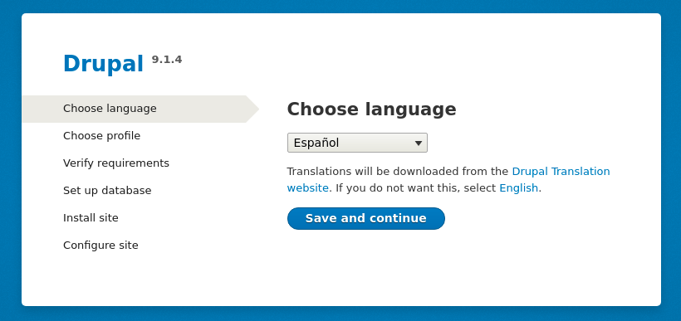

Select the type of installation we want to have:

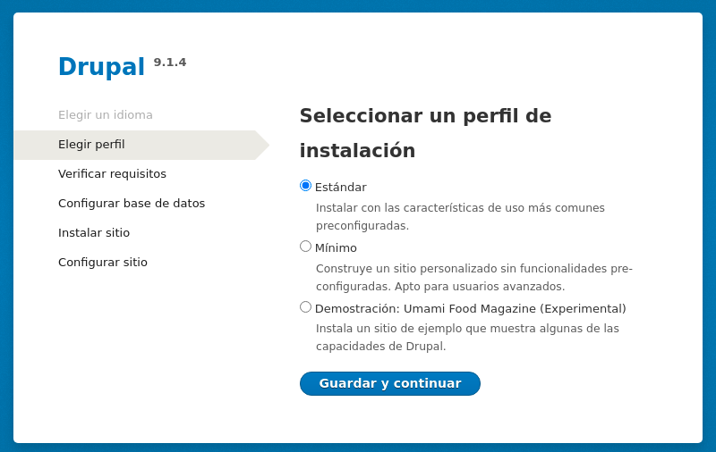

Configure the created Data Base Values:

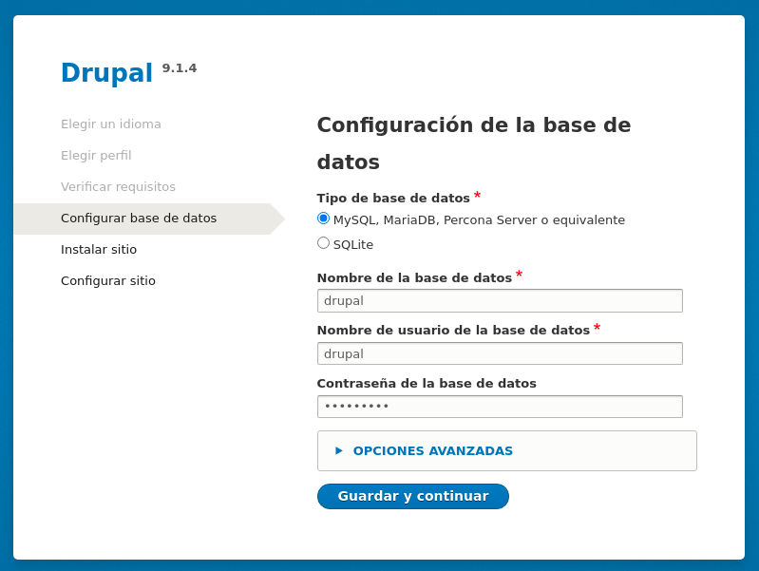

Wait it to make the necessary installation

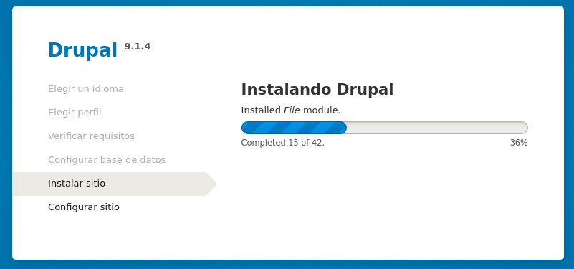

Configure the web site

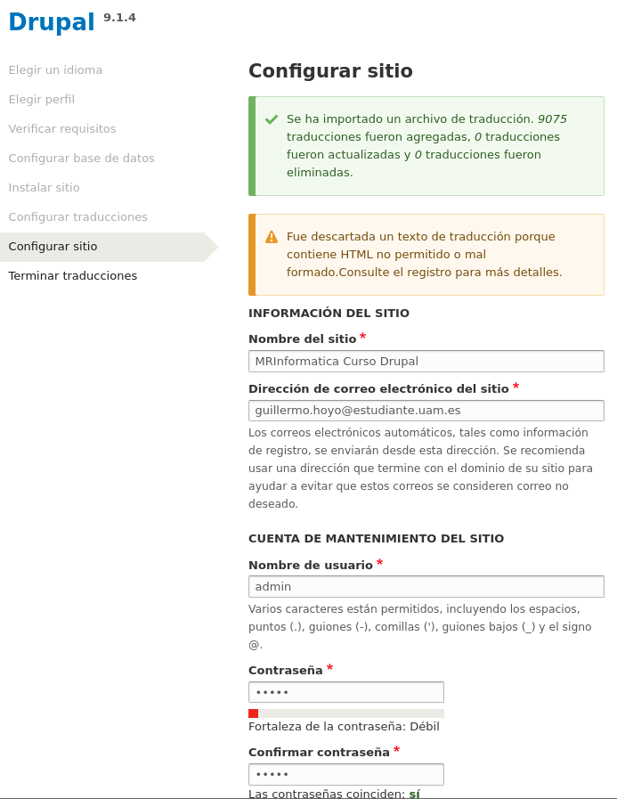

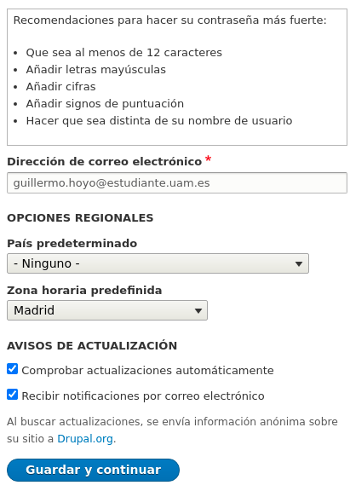

Wait to actualize and to finish the download

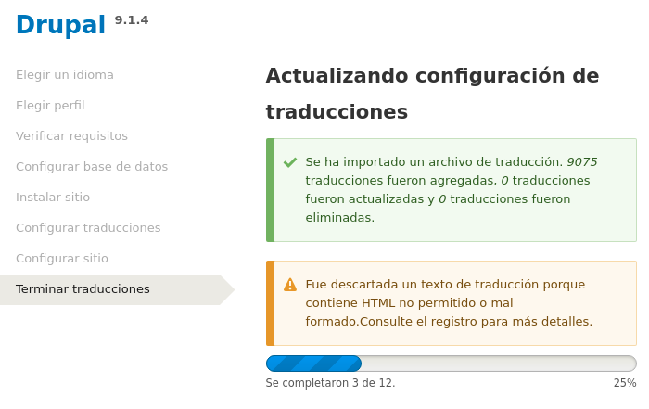

Congratulations!! You can start using Drupal to create your first website.

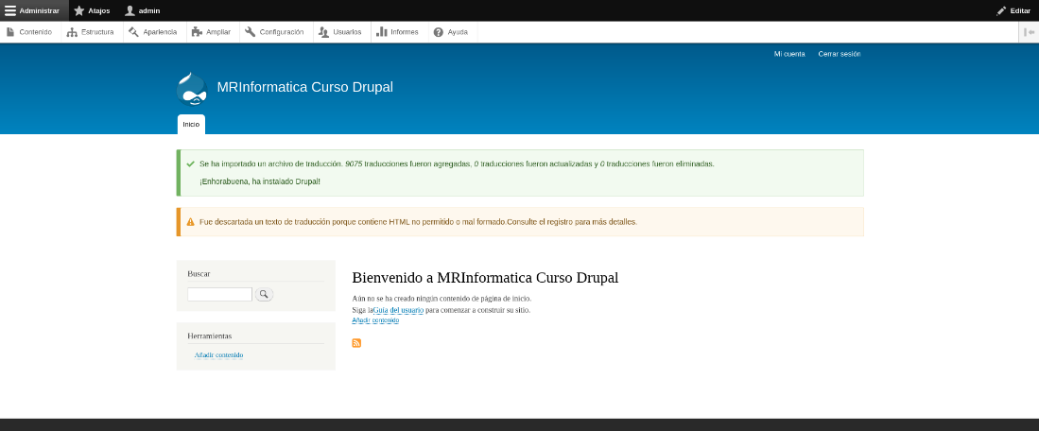

**REFERENCES**

INSTALL DRUPAL:

<https://comoinstalar.me/como-instalar-drupal-en-centos-7/>